Ecology

Multiple Choice
Identify the choice that best completes the statement or answers the question.

____ 1. Why are invasive species able to displace many species in an area?
a. | They are in an environment where they are better able to deal with diseases and parasites | c. | They have a very narrow realized niche but they are very able to use all of the available resources
b. | They are in an environment that has not adapted to them and they can take over many niches at once | d. | They wait for the right moment to attack so you never see them coming.

____ 2. When Mr. Curry hikes around Marrott Park with his dog he notices Canadian geese, red-eared slider turtles, minnows and many species of trees. What level of organization has he noticed?
a. | cell | c. | ecosystem
b. | individual | d. | community

____ 3. All of the possible biotic and abiotic factors that an organism can take advantage of is the...
a. | hopes and dreams | c. | ecosystem
b. | realized niche | d. | fundamental niche

____ 4. When Mr. Curry hikes around Marrott Park with his dog he notices Canadian geese, red-eared slider turtles, minnows and many species of trees. What level of organization has he noticed?
a. | individual | c. | ecosystem
b. | community | d. | cell

____ 5. Which population would be more affected by a loss of producers; rabbits (primary consumers) or wolves (secondary consumers)?
a. | rabbits | c. | wolves
b. | the producers | d. | none of the above

____ 6. An organism’s niche is
a. | the range of physical and biological conditions in which an organism lives and the way in which it uses those conditions.
b. | all the physical and biological factors in the organism’s environment.
c. | a full description of the place an organism lives.
d. | the range of temperatures that the organism needs to survive.

____ 7. The most important abiotic factors in a biome are..
a. | prevailing winds and ocean currents | c. | types of animals and plants
b. | altitude and prevailing winds | d. | temperature and rainfall

____ 8. A snake that eats a frog that has eaten an insect the fed on a plant is a:
a. | secondary consumer | c. | tertiary consumer
b. | primary consumer | d. | producer

____ 9. An organism that feeds on other organisms called a(n):
a. | detritivore | c. | heterotroph
b. | autotroph | d. | carnivore

____ 10. The total mass of living tissue at each trophic level can be shown in a(n):
a. | biogeochemical cycle | c. | pyramid of numbers
b. | biomass pyramid | d. | energy pyramid

____ 11. When two organisms live in a dependent relationship that relationship is a
a. | parasitism.
b. | commensalism.
c. | symbiosis.
d. | mutualism.

____ 12. The series of steps in which a grizzly bear eats an elk that has eaten grass is a(n):
a. | pyramid of numbers | c. | food chain
b. | food web | d. | biomass pyramid

____ 13. Energy for most life comes from:
a. | sunlight | c. | producers
b. | autotrophs | d. | consumers

____ 14. An interaction in which one organism captures and feeds on another organism is called
a. | competition. | c. | predation.
b. | symbiosis. | d. | mutualism.

____ 15. Where does 10% of the energy from each trophic level go?
a. | heat | c. | into nutrient cycles
b. | the next trophic level | d. | all of the above

____ 16. All of the blue gill (type of fish) in Eagle Creek Reservoir: what level of organization have I described?
a. | organism | c. | population
b. | community | d. | biosphere

____ 17. Which population would be more affected by a loss of producers; rabbits (primary consumers) or wolves (secondary consumers)?
a. | the producers | c. | rabbits
b. | wolves | d. | none of the above

____ 18. Why are invasive species able to displace many species in an area?
a. | They are in an environment where they are better able to deal with diseases and parasites | c. | They wait for the right moment to attack so you never see them coming.
b. | They are in an environment that has not adapted to them and they can take over many niches at once | d. | They have a very narrow realized niche but they are very able to use all of the available resources

Matching

Match the type of symbiosis described below with its description.
a. | parasitism | d. | predation/herbivory
b. | mutualism | e. | competition
c. | commensalism

____ 19. a raccoon eats grubs from the ground

____ 20. a tick sucks blood from a dog

____ 21. a sea anemone provides housing for a clown fish while the clown fish attracts prey for the anemone

____ 22. a remora eats the remains of shark kills while not affecting the shark

____ 23. sparrows and nut hatches eat grass seed from the same yard.

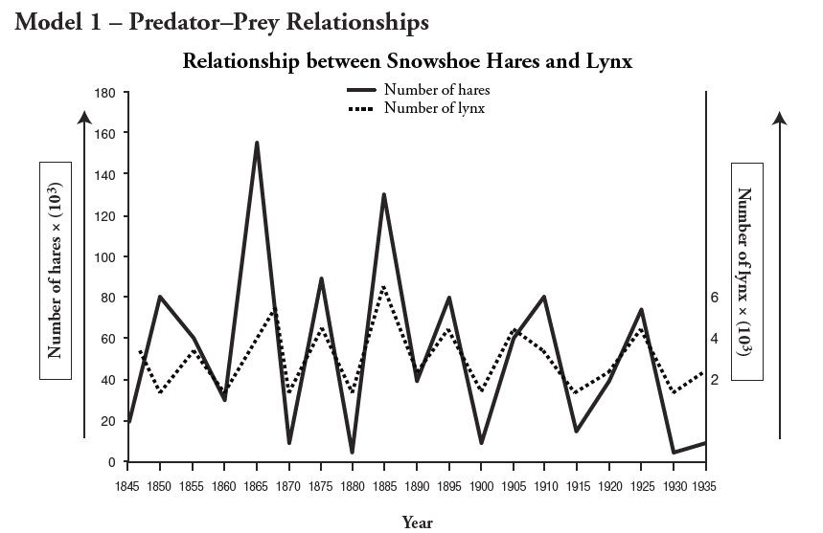

24. A researcher notices that the population of hares in increasing from 1930 to the end of the graph. What would be a reasonable prediction for what the population of lynx will do?

- Increase at a similar rate to the population of hares
- Increase more rapidly than the hares
- Decrease until the hare population becomes stable
- Remain unchanged

25. If lynx population were to go above the hare population, what would be the likely effect on the hare population?
a. It would increase along with the lynx
b. It would rapidly decrease due to increased predation
c. It would remain stable because there is no relationship between lynx and hare populations
d. It would decrease but due to disease

26. Why is the population of lynx approximately 1/10th that of the population of hares?
a. Lynx are at a lower trophic level than hares so there are usually fewer of them
b. Hares are the primary food source for lynx so only 1/10th of the energy of the hares is actually able to be turned into biomass for the lynx
c. Lynx compete more with each other than hares so there are always fewer lynx
d. lynx hate crowds

27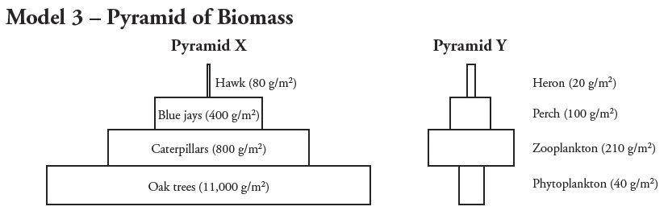

27. How can pyramid Y exist with a smaller biomass at the producer level?

- Phytoplankton are very nutritious so not as many are needed to support an ecosystem

- Animals in aquatic ecosystems do not need to eat as much

- Phytoplankton reproduce rapidly so they can support an ecosystem even at a lower biomass

- This pyramid cannot exist

28. If hawks were only feeding on blue jays (this would never actually happen) and the blue jay biomass dropped to 150 g/m² what would happen to the hawks in Pyramid X?
a. They would start eating the oak trees

b. They would disappear from this particular model because there would not be enough biomass to support them
c. They would become prey for the caterpillars
d. They would be replaced by a smaller predator

