Name:______________________________

The *Lac Operon*, a Simple Model of Genetic Control

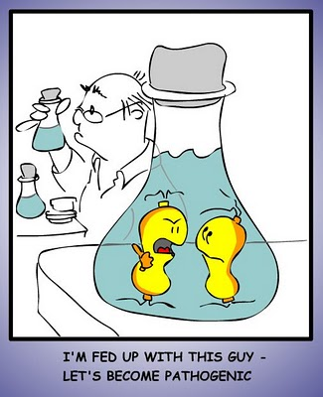

*Escherichia coli,* or *E. coli* as it is known to friends is a common bacteria found in the lower intestines (bowels) of most warm blooded animals including YOU! Don’t worry though, *E. coli* is part of the intestine’s normal flora, or organisms that are necessary to help with digestion and prevent harmful bacteria and fungus from growing and making you sick.

So what is *E. coli* doing down there? It is mostly doing what every other organism needs to do; consuming nutrients and reproducing. When you live in the gut of an animal you have to take what you can get for food so *E. coli* has a number of genes under **regulation** so it can turn on and off specific enzymes when a particular energy source becomes available. One possible food source for *E. coli* is lactose or milk sugar. Lactose becomes available for many mammals when their young consume milk. *E. coli* is able to break this down as a food source by turning on a set of genes packaged together called an **operon**. The specific operon for the breakdown of lactose is called the ***lac* operon.**

***Question:*** Why would it be beneficial for an organism to be able to turn genes on and off as different conditions occur in its environment (e.g. different food sources come and go)?

We will be using a computer simulation then a 3D model to demonstrate the function of the *lac* operon.

Go to this site: [University of Colorado, PHET Lac Operon Simulation](http://phet.colorado.edu/en/simulation/gene-machine-lac-operon)

Click “Run Now!”

Allow the computer to run the downloaded file.

The *lac* operon is demonstrated by a diagram that looks like this:

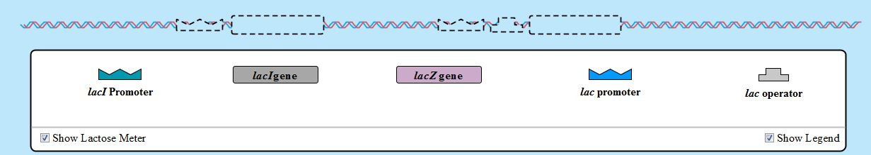

Click on these boxes to turn on the lactose meter and the molecule legend

Step 1: Drag the lac promoter to the stretch of DNA. Do NOT drag the lacZ gene to the DNA. What happens? Why is this?

Step 2: Now try dragging the lacZ gene to the DNA and note what happens.

Step 3: Inject some lactose (about 25 molecules should do it) into the simulation. Note what happens. Specifically, what is lactose being converted into?

Step 4: Note that the lac enzyme continues to be produced even in the absence of lactose. Why is this a problem? Try dragging the lac operator gene onto the stretch of DNA. What is the result?

Step 5: Now try adding the lacI promoter and gene to the stretch of DNA. What happens?

Step 6: Again, add some lactose (and again, 25 molecules should work well) into the simulation. What is the INITIAL result of adding lactose when both genes are activated?

Step 7: Do not add any more lactose and watch what transpires. Note what happens and why this occurs. How could you re-activate the lacZ gene?

Model:

Materials representing the different players in the control of the *lac* operon are available to you at the back of the room. Use these to demonstrate the control of the *lac* operon (specifically the control of lacZ) in lab groups. Each person in your group needs to control one aspect of the operon and demonstrate the operon:

1. Without lactose present
2. With lactose present

Mr. Curry’s Initials (10 pts.)______________