Name:__________________________

Mutation Study Guide

1. Define what a mutation is:

2. What is the difference between mutation in a somatic cell and a germ line cell?

3. A point mutation is the change in ____________________ nucleotides in a gene.

4. When a mutation changes the DNA but not the protein it is a _________________ mutation.

5. A ____________________ point mutation (substitution) is when the mutation changes an amino acid.

6. A ____________________ point mutation (substitution) is when the mutation changes a codon for an amino acid to a stop codon.

7. Insertions and deletions are called ____________________ mutations because they change the reading fame of the codons.

___________________ add an extra nucleotide while __________________ removes a nucleotide.

8. Rank the severity of the various types of point mutations from 4 (most severe) to 1 (least severe)

9. The result of a mutation depends on how it changes the ________________ sequence of the protein.

10. How does each of the following cause you to have a mutation?

a. Inheritance:

b. Replication errors:

c. Mutagens:

11. What type of mutation causes sickle cell anemia? How many amino acids are changed in the protein?

12. Why are frameshift mutations so damaging?

13. How are frameshift mutations involved with cancer?

14. Any change in chromosome numbers is called a _____________________.

15. Nondisjunctions happen when ______________________ fail to separate in *anaphase I* or _______________ fail to separate during *anaphase II.*

16. When do most chromosomal mutations happen?

16. Label each of the following chromosomal mutations and give a brief description of what is happening:

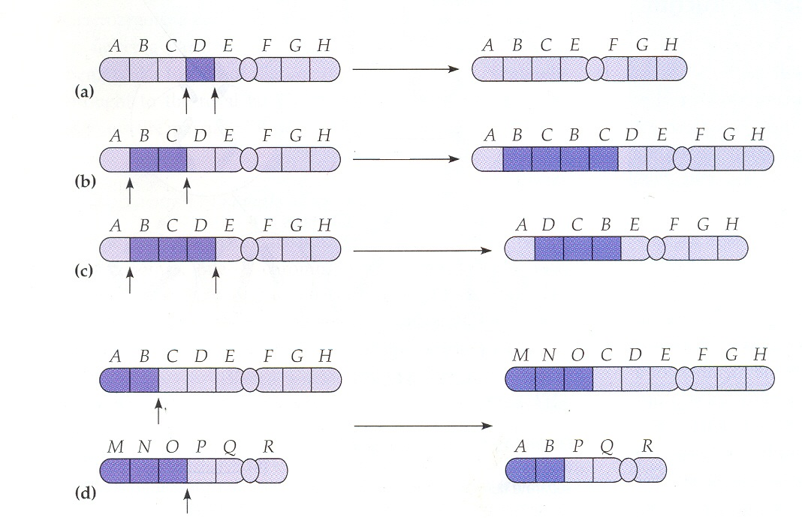

(The Philadelphia Translocation is a translocation between chromosomes *9* and *22* NOT 7 and 22 like I said in the video)

Use this link to view the bad video from pbs: <http://www.pbs.org/wgbh/evolution/library/01/2/l_012_02.html>

17. Why is it an advantage for people in West Africa to carry the sickle cell allele?

18. Using natural selection explain why people of West African ancestry have a much higher rate of sickle cell anemia:

Variation-

Overproduction of offspring-

Struggle for existence-

Differential reproduction-