Name:________________________
Translation Study Guide
1. The process of translation takes the information contained in ________ and converts it into ________.
2. ____________ must be spliced out of the original mRNA. Exons are the pieces of ___________ that contains information for protein.
3. RNA splicing happens in the __________________.
4. Why do prokaryotes not do RNA editing?

5. Diagram how mRNA is spliced below, label the introns, exons, and spliceosome.

6. Sketch each of the following and give a brief description of their role in translation:
a. mRNA:

b. ribosome:

c. tRNA:

d. codon:

e. anticodon:

f. amino acid:

7. Label the following on the diagram: ribosome, rRNA, tRNA, mRNA, amino acid, codon, anticodon, forming polypeptide (protein).

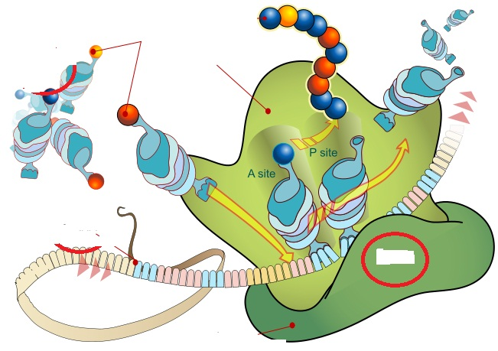

8. Translate the following mRNA:
AUG GCU CCC UGU GAG AAA CAG UGA

9. Why can so many proteins be made by the 20 amino acids?

10. What are two questions you have after watching the presentation?
a.
b.

